Brighton Centre
Access Statement

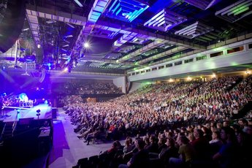

Contents

Introduction

Getting Here and Parking

Arriving at the venue

Making your way around the venue

Accessible Toilets
Assistance Dogs

Quiet Spaces

Medical Assistance
Emergencies

Additional information
Introduction

The Brighton Centre is a multi-purpose venue in the centre of Brighton and is one of the largest purpose built events venues on the South Coast of England. We offer a warm welcome to everyone and aim to offer an excellent level of service to all our customers. We really want you to enjoy your time with us so if anything happens while you are at the Brighton Centre, please speak to one of our staff and ask to speak to the Duty Manager who will deal with your queries as best they can. All front-line staff have undertaken accessibility training and will do their best to ensure your visit is both enjoyable and safe.

The venue hosts a wide variety of events throughout the year including musical concerts of all genres, comedy shows, larger theatre productions such as Holiday on Ice, and public exhibitions. Full details of all forthcoming events are available on the Brighton Centre website.

The main auditorium can hold a maximum of 4,270 for a seated event and up to 5,515 for a standing concert. There is a second, smaller auditorium in the Syndicate Wing (next door) which hosts occasional smaller concerts and is also used as part of the whole venue for some larger events

The Brighton Centre offers:
- Accessible toilets
- A Changing Places facility
- Accessible lifts
- Box Office, Information Desk and bars with low level counters
- Box Office, Wristband Exchanges, Security and Information Desks with induction loops
- Staff who have undertaken accessibility awareness training
- Accessible viewing platforms
- Free ticket for a Personal Assistant (subject to availability)
- Dedicated Access Line for enquiries & booking accessible seating
- A Gold Award from “Attitude is Everything”

Getting Here and Parking

The Brighton Centre is located in the heart of the city on Brighton seafront. We’re easily accessible via public transport and are a short distance from Brighton Mainline Railway Station, Pool Valley Coach Station, city centre bus stops and taxi ranks; we also have our own cycle racks located at the front and rear of the venue.

Our full address is Brighton Centre, Kings Road, Brighton, BN1 2GR.

Parking

If you are arriving by car, the nearest public car parks are Churchill Square Car Park which gives very easy flat access to the rear doors of the venue, and to the Syndicate Wing, and Regency Square Car Park, which gives flat, level access along the seafront to the main doors at the front of the building. Please note that the car parks close to the venue can get very busy when shows finish and there may be a queue to exit.

Churchill Square Car Park 1, BN1 2RU

Full information on the car park, including parking charges, is available on the Churchill Square website.

The entrance to the car park is via West Street. We advise customers to access this from the seafront road (Kings Road) as there is no right turn available if you are coming down West Street from the top of the road.

The height restriction of the car park is 2.13 metres.

Lighting in the car park is good.

There are accessible parking bays on all levels of the car park, but customers are advised to park on the lowest level if possible (Parking Level P1). If you park on a different level you will need to use the accessible lift to take you down to Parking Level P1 in order to exit the car park.

The distance from the car park exit to the venue is approx. 30 metres. There is level access across the road with dropped kerbs via the pedestrian crossing next to the car park exit. Assistance is available via a call button if you need help when paying.

Churchill Square car park exit:

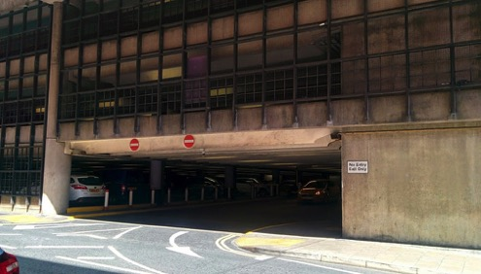

Rear entrance to the Brighton Centre:

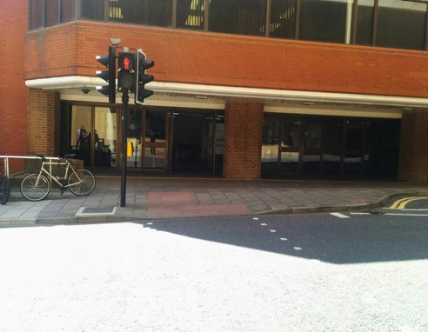

Regency Square Car Park, BN1 2FG

Full information on the car park, including a video and parking charges, is available from the parking pages on the council's website.

This car park is a good option if you wish to access the Box Office and the main entrance to the venue, which are both on Kings Road, on the seafront.

The entrance to the car park is via Kings Road, opposite the old West Pier.
The height restriction of the car park is 2.5 metres.

This is an underground car park. Customers are advised to park on the lowest level for ease of exit. Please note there is no lift in the car park.

The distance from the car park to the venue is approx. 250 metres. There is a short incline on leaving the car park but then the journey to the venue is flat and level with dropped kerbs at each junction along the seafront to the venue.

Assistance is available via a call button if you need help when paying.

Lighting in the car park is good.

Regency Square Car Park interior:

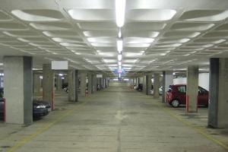

Regency Square Car Park exit:

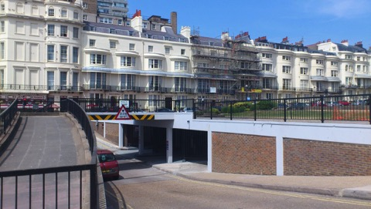

Blue Badge parking and drop offs

There are designated Blue Badge parking bays close to the venue in West Street and Cannon Place but please note that those in Cannon Place are on a hill going down to the seafront. Blue Badge holders can park free of charge and without any time limit in these bays.

There is a lay-by in front of the venue which has double yellow lines. This is ideal as a drop-off point. Please note that there is no dropped kerb directly in front of the centre. Wheelchair access is available at the rear entrance (Russell Road).

Lay-by in front of the Brighton Centre:

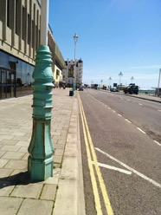

Blue Badge holders can also park for up to 3 hours on any single or double yellow line near the venue as per usual Blue Badge regulations, as long as you are not on a corner or causing an obstruction, and as long as you set the arrival time on the clock on your Blue Badge.

Taxis

If you need to book an accessible taxi we recommend the following taxi firms, all of which have accessible taxis in their fleets:

Brighton & Hove City Cabs: Tel 01273 205205 www.205205.com
Brighton and Hove Radio Cabs: Tel 01273 204060 www.brightontaxis.com
Brighton & Hove Streamline Taxis: Tel 01273 202020 www.streamlinetaxis.org

There are free taxi-phones that can be used to call a taxi inside the venue.

Buses

If you are coming to the venue by local bus, the nearest bus stops are outside Churchill Square shopping centre in Western Road. This is approx. 700 metres from the rear entrance to the venue. Please note that access is via West Street which is on a hill. All city buses operated by Brighton & Hove Buses are accessible for wheelchair users. They also operate a “yellow card” scheme where you can alert the bus driver to any specific needs (eg please tell me when I get to my stop/please wait for me to sit down before you set off). More information is available on the Brighton & Hove Buses website.

Train

If you are arriving by train you need to exit the station via the main exit at the front leading to Queens Road. From here there is step free access to the seafront and the Brighton Centre. This is approx. 950 metres from the rear entrance to the venue. There is also a taxi rank outside the station should you need one.

PhotoRoutes

You can see the route from Brighton Station on the VisitBrighton website PhotoRoutes page. The maps also show other routes around the city.

PhotoRoutes use a simple map based system, with images of each junction, showing a step-free route to your destination. The PhotoRoute from Brighton Station to the Hilton Brighton Metropole Hotel will show you the route to the Brighton Centre, located on Kings Road, on the right, just past the junction with West Street, approx. 100 metres before Point 8 on the map. A direct link to this photo route is available here.

Shopmobility

There is a Shopmobility service operated by the FED Centre for Independent Living. The service is available from three locations in Brighton: Churchill Square Car Park, Kemptown and London Road. To book please call 01273 323239 for more information. Normal opening times are Monday to Friday, 10am to 4pm. Winter times are subject to change. More information is available from the Shopmobility website.

Arriving at the venue

When arriving at the Brighton Centre there are two entrances into the venue; on the seafront (Kings Road), and at the back of the building on Russell Road.

All entry doors into the venue are retained in the open position when events are taking place, unless there are high winds on the seafront when they will be kept closed for safety reasons but manned by a member of staff. The clear door opening width of all entry doors is 1600mm.

The quietest entrance to the venue is at the back on Russell Road.

Access via the front entrance – Kings Road

There is step-free access via the front doors of the venue into the main foyer.

The floor surfaces are all smooth and level and the lighting levels are good.

Main entrance to the venue and the box office:
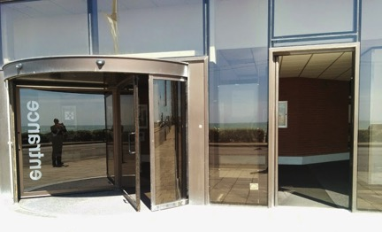

Internal entrance leading to main foyer:

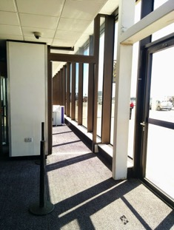

Main foyer:

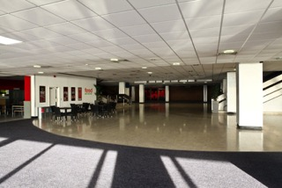

There are accessible lifts to take you to all floors of the venue from the main foyer.

Access via the rear entrance – Russell Road

Access via the Russell Road doors is step-free, and there is an accessible lift to take customers to the required floor.

The floor surface is level and carpeted, and the lighting levels are good.

Rear foyer:

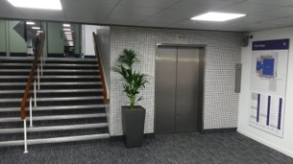

Access to the Syndicate Wing – Russell Road

Access is level to the doors of the Syndicate Wing and there is an accessible lift to take you to the first floor if required. Accessible toilets are also available on the ground floor.

The floor surface is level and carpeted, and the lighting levels are good.

Syndicate Wing foyer:

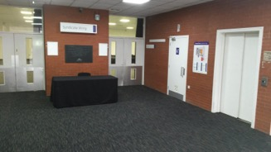

There is also a ramp which connects the main venue with the Syndicate Wing. The ratio of the ramp is 1:15. The floor surface of the ramp is carpet, and the lighting levels at the ramp are good.

Ramp access to the Syndicate Wing:

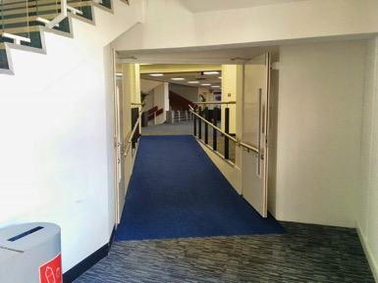

Making your way around the venue

If you have any problems, questions or require additional support please speak with a member of stewarding staff or security who will be happy to assist you and answer any questions.

Lifts:

Whichever entrance you use there are accessible lifts to take you to the floor you need.

Sizes of all lifts are:
Door width – 1100mm
Floor depth – 1700mm
Floor width – 1950mm

- All lifts have audible announcements for each floor level.
- The signage inside the lifts includes pictograms.
- There is currently no tactile or Braille information in the lifts.
- There is currently no inductive coupler in the lifts.

Lift entrance:

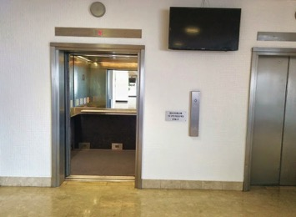

Lift interior:

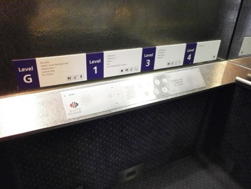

Stairs

There are also stairs to take you to all levels of the main venue which have handrails on both sides.

Stairs from main foyer to 1st floor:

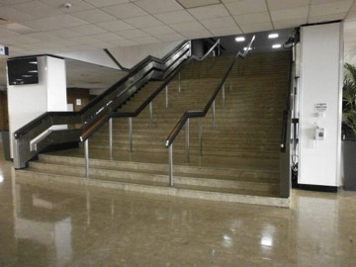

Stairs from rear foyer to 1st floor:

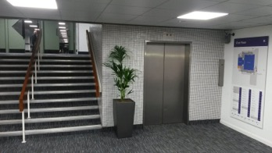

Auditorium 1 & 2

There is level access into both auditorium areas.

All floor surfaces are smooth and level.

Syndicate Wing

There is level access from the street into the Syndicate Wing, or there is an internal ramp which connects it to the main part of the venue. The ratio of the ramp is 1:15.

Ramp access to the Syndicate Wing:

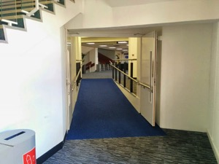
Accessible Toilets

There are accessible toilets on all floors in both the main venue and the Syndicate Wing.

- All toilets have level entry
- All floor surfaces are smooth and anti-slip
- All areas are well lit
- The door clear opening width to all the toilets is 760mm
- The locks can be opened from outside in an emergency
- There is clear floor space in all the toilets up to 1200 x 1200mm
- There is right and left hand transfer to the WC
- The space beside the WC is 800mm
- Vertical rails are fitted beside the WC
- Most WC seats have lids
- The basin taps are lever taps
- Hot water temperature is controlled at the point of delivery
- There is a strobe light linked to the fire alarm
- There is an emergency cord
- There are colour contrasts between surfaces
- There is clear signage to all toilets
- There are baby changing facilities on the ground floor
- There are accessible toilets close to all accessible platforms

Accessible toilet:

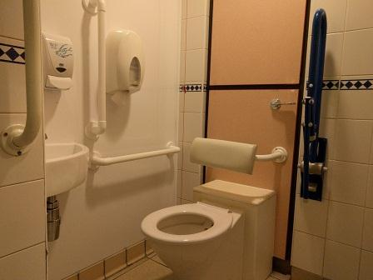

Food and Drink

There are two main bars available at most events. These are located on the East and West concourses that run alongside Auditorium 1. There are also cafés on these concourses. There is also a café area available on the ground floor next to the Box Office.

- All food and drink areas have level access
- The clear opening door width to the café is 1600mm and the minimum clear space opposite the doors is 2500mm
- There is space between the furniture and clear space under the tables is 680mm
- There are low level counters at the bars
- Tableware contrasts with the tables
- All bar and café prices are available in large font on request
- Dietary needs can be catered for, please contact us if you have a specific requirement
- All areas are well lit and the floors are level and anti-slip
- There are accessible toilets close to all the food and drink areas
- Hot food and hot drinks are not permitted in the auditorium

Low level counter at bar:

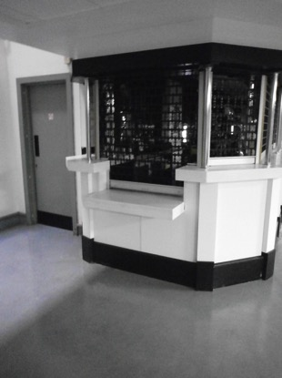

Assistance Dogs

Brighton Centre welcomes assistance dogs. We can provide water bowls for your dog if required. There is no designated spending area within the immediate area, but waste bags can be disposed of in bins outside the front entrance on the seafront and at the back on Russell Road.

Quiet Spaces

The Brighton Centre is a compact venue and therefore does get very busy however, some areas are quieter than others on show nights.

Entering via the back of the venue on Russell Road is the quietest option and usually has little to no queues.

Of the main bars the West Bar is generally quieter and seating is available. The venue medical room is also located off the West Bar and can be used as a quiet space.

If you are feeling uncomfortable or would like to be shown to a quiet space please ask a member of stewarding staff or security who will be happy to assist you.

Medical Assistance

Trained First Aiders are available for all events and can be summoned by stewards. There is also a First Aid Room available at all events, which can also be used as a quiet space.

Emergencies

In the event of an emergency there will be both an audible alarm in all areas, as well as flashing lights in the main auditorium and strobe lights in the accessible toilets. Stewards will ensure the safe exit of all people.

There are Evacuation Chairs available. These have a safe working load of 136kgs, and staff are trained to use them.

All areas of the venue have emergency evacuation plans including the accessible areas.

Our staff are fully trained in the evacuation of the venue and each accessible area has a specially trained member of staff who is able to evacuate people from the accessible areas.

If you would like further information on the plan for the area please do not hesitate to contact us in advance or speak to a member of our stewarding staff when you arrive at the venue.

Additional Information

General information about the city including places to stay, things to do and what’s on is available from the VisitBrighton website. There is a dedicated section on accessibility which includes downloadable information sheets, and information on accessible toilets, parking and Shop Mobility.

Care has been taken to ensure that the information in this Access Statement was correct at the time of publication. If you need any reassurance about any aspect of the venue’s accessibility please contact us.

Published: May 2016
Review Date: August 2016

